**Impact of Female Mating Status on Male Courtship Behaviour in the Sexually Cannibalistic New Zealand Fishing Spider *Dolomedes minor* (Araneae, Dolomedidae)**

Bastien E. Clémot1,2, Simon J Connolly2, Christina J Painting2.

1 Department of Biology, Lund Vision Group, Lund University, Lund 223 62, Sweden

2 Te Aka Mātuatua School of Science, University of Waikato, Hamilton 3240, New Zealand

**ABSTRACT**

* The evolution of male courtship has traditionally been attributed to female mate selection, but may also hinge on male investment strategies in sexually cannibalistic species. In many spider taxa, males perform energetically costly courtship behaviours to enhance their chances of mating success while minimising the risk of predation by females. Consequently, when courting already mated females, males would be expected to make evolutionary trade-offs in their courtship investment, balancing the risk of sexual cannibalism and the costs associated with sperm competition. Despite the occurrence of sexual cannibalism, the mating behaviour of the New-Zealand nursery-web spider *Dolomedes minor* remains poorly understood. While addressing this gap of empiric knowledge, we therefore investigated how female mating status influences male courtship investment in this species. Laboratory observations of 15 first unmated females, each mated twice, allowed for comparisons of courtship behaviours displayed by the first and second males. Our findings provide the first detailed description of Dolomedes male courtship behaviour, revealing vibrational and visual communication cues similar to those documented in Lycosid and other Pisaurid spiders. Contrary to expectations, we found that female mating status did not significantly affect male courtship duration or sequence structure. These results open the door for further exploration of other communication modalities, such as chemical and tactile signals, that may play a role in male assessment of female condition and reproductive potential.add in an abstract here that has a couple of intro senetneces giving the background concepts and what is important; a sentence or two that introduces the species & what question is; what the methods are; key results; and a wrap up sentence or two stating significance/key take home messages. ADDED

**INTRODUCTION**  In a quest for reproductive success, male spiders must weigh the fine line between optimising mating opportunities and avoiding the irreversible consequences of sexual cannibalism. Courtship is a key way in which animals, especially males, increase their reproductive success through mate attraction and receptibility (Andersson & Iwasa, 1994). It covers a wide range of sensory modalities used by males to facilitate and engage in reproduction with females (Bastock, 1967). For instance, salamanders exhibit visually attractive colour patterns (Ancillotto *et al*., 2022), eared moths engage in ultrasonic communication (Nakano *et al.*, 2015), songbirds perform duet dancing (Soma *et al.*, 2019), and male cockroaches produce nuptial secretions aligning with female taste preferences (Wada-Katsumata *et al*., 2023).

Although courtship behaviours can enhance reproductive success (Andersson & Iwasa, 1994), they can also entail energetic and survival costs. These costs have been demonstrated through increased physiological expenses, such as lactate production in crickets (Mowles, 2014), energy use during acrobatic courtship in golden-collared manakins (Barske *et al.*, 2014), and survival costs associated with predation risk in firefly light signals (Woods *et al.*, 2007). Consequently, males must make careful decisions to adjust their courtship effort when assessing the reproductive value of the female is possible (Servedio & Lande, 2006). In such cases, mating with an already mated female may result in a lower fitness payoff due to sperm competition with other males and a reduced likelihood of paternity compared to mating with an unmated female (Parker, 1970; Thomas & Simmons, 2007). This phenomenon has been widely documented, for example, in chameleons, where courtship behaviours differ based on female reproductive condition (Kelso & Verrell, 2002), as well as in bees , where males are more attracted to and detect virgin females through chemical cues (Ayasse *et al*, 1999; Kukuk, 1985.

Spiders are a particularly interesting group to study when considering the decisions a male makes to adjust courtship efforts based on the relative costs and benefits of mate choice. Indeed, they demonstrate a wide range of communication signals and courtship behaviours employing various sensory modalities (Robinson, 1982). For example, peacock spiders utilise elaborate dances, bright colours, and vibrations (Girard *et al.*, 2015), wolf spiders engage in vibrational communication (Chiarle *et al*., 2013), and gift-giving spiders present nuptial food gifts (Prokop & Okrouhlík, 2021). Importantly, courtship in male spiders can be particularly costly as females are typically aggressive, and many species exhibit sexual cannibalism (Arnqvist & Henriksson, 1997; Elgar, 1992; Robinson, 1982; Schneider & Elgar, 2001). While sexual cannibalism can be adaptive for the male if it occurs after copulation, as it may provide nutrients to the female and increase reproductive success, it is extremely costly if the female consumes the male before sperm transfer, as the male’s reproductive investment is lost (Andrade, 2003; Miller, 2007). Female aggression, therefore, introduces an important constraint on male mating choice, limiting the number of matings they can engage in, sometimes even to a single mating in species with obligatory mate consumption (Elgar, 1992; Knoflach & Van Harten, 2010). Consequently, male spiders are expected to face significant limitations on their reproductive opportunities, highlighting the importance of carefully selecting the best female based on her reproductive potential.

Male choosiness has been widely investigated in spider groups where sexual cannibalism occurs, showing that males generally prefer to mate with unmated females to reduce sperm competition and avoid increased aggressiveness in already mated females (Gaskett, 2004; Herberstein *et al.*, 2002; Schneider *et al.,* 2015). Some studies have also directly shown that costly courtship traits are adjusted over successive matings and depending on female condition, as a proxy of their reproductive value (Cargnelutti *et al.,* 2021; Solano-Brenes *et al*., 2021). The ability of males to assess female mating status and adapt their behaviour is primarily associated with chemical cues released by the female into the air or through contact with her silk (Cayet & Schneider, 2020; Copperi *et al.*, 2019; Thomas, 2010; Xiao *et al*., 2015). However, the mechanisms underlying male decision-making behaviour are highly complex and vary across spider species and populations, as males also integrate other factors such as costs related to female availability or their own condition (Schneider *et al.*, 2015; Tuni & Berger-Tal, 2012).

Fishing spiders in the genus *Dolomedes* (Dolomedidae) constitute a diverse group of over 100 species, with several species studied extensively in the context of courtship, mating system evolution, extreme male mating behaviours, and female aggression (reviewed in Yu *et al*., 2024). Sexual cannibalism has been widely reported across *Dolomedes,* and can comprise a significant component of their diet (e.g. 5% in *D. triton*) (Zimmermann & Spence, 1989). Additionally, studies have explored the significance of vibrational signals in courtship behaviours in *Dolomedes* species, where males use vibrational signals to attract mates and communicate with females (Yu *et al*., 2024). However, courtship descriptions are currently lacking for the majority of *Dolomedes* species, and we know very little about how males may adjust their courtship efforts based on female aggressiveness and sexual cannibalism risk. Research has also suggested that male courtship could vary according to female mating status, but further investigation is needed to understand how male strategies are influenced by these factors across different species in the genus.

*Dolomedes minor* is endemic to New Zealand, where it primarily inhabits near-water vegetation habitats and is mainly active from November to May during the austral summer (Vink & Dupérré, 2010). While little is known regarding the courtship behaviour of *D. minor* recent findings from Connolly (2024) suggest biandry and potential polyandry in the female of this species, with confirmed cases of sexual cannibalism. Nonetheless, it should be noted that precopulatory sexual cannibalism was shown to be rare and postcopulatory cannibalism occurring at a low frequency, and that *D. minor* exhibit female attack frequency in her sister species *D. aquaticus*. In this context, we investigate whether male *D. minor* adjust their courtship behaviour based on female mating status. We predict that when encountering an already mated female, males will exhibit shorter courtship and mounting behaviours, as well as distinct courtship structures to allocate less energy in comparison with males courting unmated females. To achieve these objectives, we conducted laboratory-based mating experiments using both unmated and previously mated *D. minor* females. We first describe the fine-scale courtship behaviour of male *D. minor* and then employ sequential analysis and comparisons of courtship duration to assess differences in courtship investment and structure between unmated and mated female groups.

**MATERIAL AND METHODS**

**Spider Collection and Maintenance**

Juvenile and penultimate *D. minor* individuals (N = 393) were collected from various near-water habitats on the campus of the University of Waikato (Hamilton, New Zealand). The collection took place between September 2020 and April 2021, corresponding to the summer season and the spiders’ primary activity period. Fieldwork was conducted exclusively at night, as individuals were more active and easily located using a head torch due to the reflection of their eyes. Collected individuals were brought to the Invertebrate Behavioural Ecology Lab (University of Waikato, Hamilton, New Zealand), and reared through to adulthood to ensure that all individuals had not mated before collection. Spiders were individually reared in plastic containers (150 mm x 95 mm x 60 mm) with a wet cotton pad and a piece of egg carton as an enrichment device. Individuals were fed live crickets twice a week, and containers were cleaned weekly to prevent mould growth and waste accumulation.

**Mating Assays**

Laboratory mating experiments between mature individuals were conducted from March to August 2021. Trials were performed in plastic containers (265 mm x 235 mm x 125 mm) with a mesh roof and wall on one side to serve as climbing support. Females were fed the day before the experiments to control for hunger-related aggressiveness and were introduced into the mating arena first, followed by the males 10 minutes later to allow the female to acclimate. Each female participated in one mating experiment until copulation and then in a second assay with a new set of unmated males, enabling comparison of male courtship behaviour between mated and unmated females. Mating trials were recorded for a duration of 4 hours after the introduction of the male. To analyse and compare male courtship behaviour when paired with mated versus unmated females, we analysed videos from 30 mating trials (N = 15 originally unmated females mated twice with different males) where courtship occurred at least once. In the ‘mated’ group, two males were reused in different trials, but with different females, due to limitations in spider availability.

**Description of Courtship Behaviour**

For each mating trial, we initially scored the videos using BORIS software (Friard & Gamba, 2016) to quantify the number of female attacks towards males and describe the timing of male courtship. We then scored different parameters of courtship behaviour: 1) courtship duration – the total time from the first male courtship signal (see Table 1) to the end of mounting, 2) mounting duration; the total time from the start to end of mounting (see Figure 1), and 3) latency to mount; the time taken from the start of the trial until the beginning of mounting. We then rescored each video to describe the fine-scale courtship elements of *D. minor* male courtship. A single observer performed all scoring (BC) and was blind to the mating status of the female. All trials were initially screened to compile an ethogram comprising all relevant courtship elements (Table 1). Due to the large amount of time required to code fine-scale behaviour during the maximum 4-hour mating assays, we limited our analysis of courtship structure to one bout of courtship for each trial. We chose the first courtship sequence from each trial that resulted in mounting behaviour (see Table 1 for definition), which was observed at 0.5x speed to score all observed courtship elements. Our justification for choosing the first courtship sequence, rather than the sequence that may end in copulation was that 1) not all trials ended in copulation for the mated female group, and 2) using the first courtship sequence allowed us to standardise the opportunity each male had to gain information when contacting the female during a trial. Courtship elements were considered non-exclusive as they could be performed simultaneously and were grouped into categories based on the body part used by the male.

**Statistical analyses**

All statistical analyses were performed with R (add version number & citation) and figures were made using the package ‘ggplot2’. To analyse the impact of female mating status on the timing of male courtship behaviour, we used non-parametric Wilcoxon signed-rank tests for paired values on the measured courtship duration, mounting duration and latency to mount, to account for individual variation as females were mated twice. The same analysis was performed to assess the impact of female mating status on the number of attacks she did towards the male. To compare the relationship between female mating status and fine-scale courtship behaviours, we used a sequential analysis approach (Bakeman *et al.*, 1996; *Green* & Patek, 2018; Le Grice *et* al., 2024) via the ‘igraph’ package to produce networks of transitions between elements for each group. With the behavioural sequences exported from BORIS software, we grouped all behaviours that were recorded simultaneously, as new combined behaviours. For example, when courtship behaviours were performed with legs and pedipalps at the same time, they were combined as a ‘Leg & Pedipalp Display’ behaviour. We removed all behaviours that had a duration of less than one second as we considered them to be artefacts linked to the inaccuracy of our observations and scoring. Then, we compiled the behavioural sequences previously scored and used the ‘igraph’ package to compute for each group an observed matrix of behavioural transition frequency, where each cell corresponded to the number of occurring transitions from the behaviour in row to the behaviour in column. For each group, we then repeatedly and randomly permuted all behaviours within the behavioural sequences until obtaining 10,000 new matrixes of randomly generated behavioural transitions. These matrixes gave each transition of each group their expected distribution if behaviours were randomly distributed along behavioural sequences. We extracted the 95% quantile of each distribution and compared it with the first observed matrix of transitions. Observed behavioural transitions that had a frequency higher than the calculated 95% quantile were considered to occur more often than randomly and be significantly contributing to the overall structure of courtship behaviour. After keeping only significant behavioural transitions, we plotted the behavioural structure of courtship as networks for each of the groups to compare for structural differences (Bakeman *et al*., 1996; Green & Patek, 2018). Between the two groups, we compared the frequency of each behaviour and behavioural transition with Wilcoxon mean comparison tests for paired values.

**RESULTS**

**Description of Male Courtship Behaviour**

During the mating trials, males swiftly detected the presence of the female upon introduction and initiated courtship behaviour. In contrast, the females mainly remained motionless and positioned themselves on the mesh roof or wall of the container. The males gradually approached the females during the trials, using a combination of vibrational and visual signals, until they were in close proximity to the female. We observed 14 distinct courtship elements including leg, pedipalp and abdominal motions performed in the air or by contacting the substrate (Table 1). Movements performed with legs were variable, with a total of 6 different elements described (Table 1). These leg motions were often exhibited simultaneously and independently between each leg and were sometimes performed by grabbing the female silk dragline with the tarsus. However, they were often not clearly defined and chaotically mixed, which make it difficult to always clearly and consistently distinguish them during courtship display.

Male approach towards the female involved a start-and-stop behaviour, with males continuing to perform courtship elements (as above) when near the female until suddenly mounting her. Once mounted, the males continued the start-and-stop behaviour, accompanied by sort sequences of leg and pedipalp movements aimed at repositioning. This allowed the males to bring their pedipalps closer to the female’s genitalia, with their bodies consistently positioned perpendicular to the female (Figure 1). When in close proximity, the male attempted copulation. Mounting was often repeated multiple times before successful copulation, with males occasionally retreating and starting the process again (mean = 5.87, se = 1.14 in the unmated group). In four trials out of 15 involving unmated females, sexual cannibalism occurred.

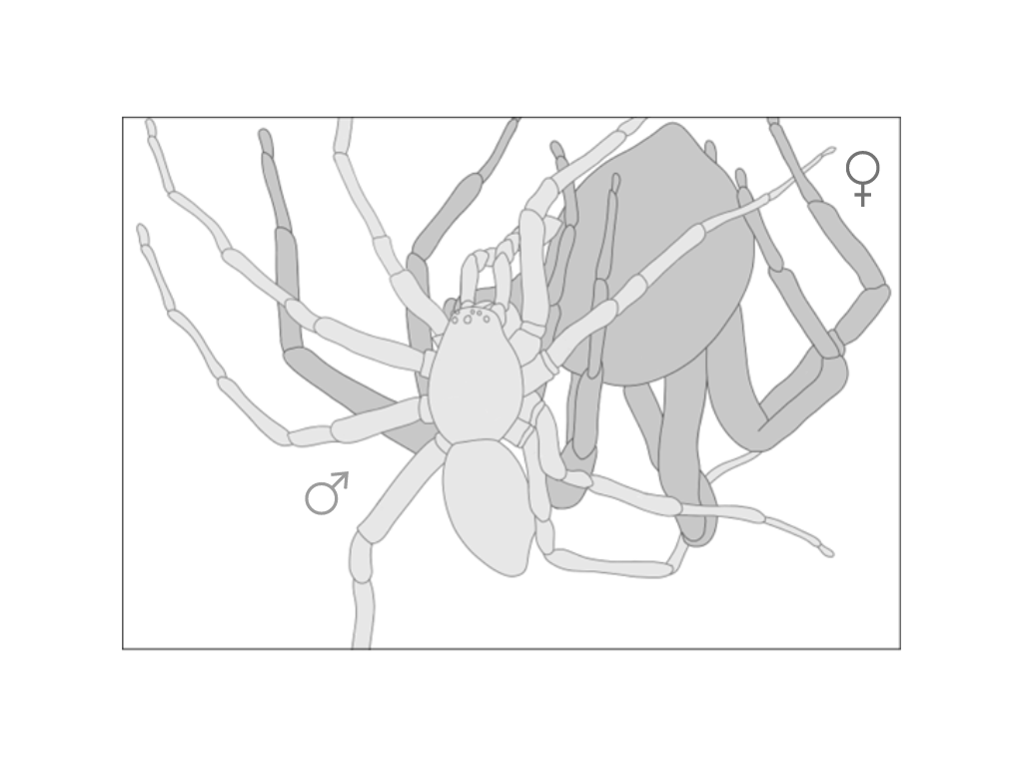

**Figure 1.** Schematic drawing of the reproductive position in *Dolomedes minor*, based on near pedipalp insertion events observed in the mating trials analysed. Male is coloured in light grey and female in dark grey.

**Table 1.** Ethogram of male courtship behaviours in *Dolomedes minor*.

|  |  |  |  |
| --- | --- | --- | --- |
|  |  | **Behaviour** | **Description** |
|  |  |  |  |
| Leg Display |  | Leg Raise | Raising of one or more of the legs, straight or slightly bent, at an angle between 50 and 90°, for at least one second without performing any specific aerial pattern with the tarsus or the rest of the leg. Behaviour ends when the leg is lowered and touches the substrate or a specific vibrational pattern is drawn with the tarsus or the whole leg (See Wave and Aerial Tremulation). |
|  | Wave | Raising of one or more of the legs, straight or slightly bent, a performing several circular or vertical fluid aerial movements with the whole leg and tarsus. Vertical movements can be performed between on a 90° angle. Behaviour ends when the leg has stopped moving for more than one second (see Leg Raise) or is lowered to touch the substrate. |
|  | Aerial Tremulation | Raising of one more of the front legs, slightly bent, performing quick and repeated vertical movements with the whole leg, freely in the air or by grabbing a female silk dragline with the tarsus in some cases. Behaviour ends when the leg has stopped moving for more than one second (see Leg Raise) or is lowered to touch the substrate. |
|  | Wipe | Following Leg Raise, Wave or Aerial Tremulation behaviours, instead of simply touching the substrate, the individual is lowering its leg straight on the site of its body and is wiping the substrate with its tarsus, always towards its cephalothorax. It is often followed by Quick Tapping. |
|  | Quick Tapping | Extension forward of one or more of the front legs with a quick tapping of the tarsus on the substrate or the female silk dragline. Sometimes performed on female legs when the male is close to a mounting attempt. |
|  | Leg Rubbing | While mounting the female, legs are bent and perform quick vertical and horizontal repeated movements. Often associated with a repositioning of the male on the female and approaching of the pedipalps towards the female genitalia. It is the only leg behaviour performed during mounting. |
|  |  | Pedipalp Display | Quick vertical and repeated movement of both pedipalps in the air, sometimes while grabbing a female silk dragline. |
|  |  | Body Surge | Sudden tap of the abdomen on the substrate with contraction of the whole body. Often paired with an abrupt tap of some of the legs on the substrate, especially when they are already raised. |
|  |  | Abdominal Tremulation | Repeated quick horizontal vibration of the abdomen performed without touching the substrate. Abdomen is mainly remaining aligned with the rest of the body. |
|  |  | Grooming | Brushing of the pedipalps, legs and chelicerae together, sometimes only two of them. |
|  |  | Approach | Locomotion towards the female accompanied by clear courtship signals. |
|  |  | Retreat | Quick moving away from the female in response to a clear signal from her such as a vibration, a movement or an attack. Behaviour can be triggered when the male is mounting the female, always leading to the end of Mount behaviour. |
|  |  | Mount | Male climbs onto the female’s abdomen. |
|  |  | Pedipalp Insertion | Extension of one pedipalp toward the genitalia of the female which leads to embolus insertion and successful copulation. |

**Influence of Female Mating Status on Female Aggressiveness**

There were no significant differences in the number of attacks emitted by unmated (mean + standard error) versus mated (mean + standard error) females towards males (W = 149, P = 0.1301; Figure 2).

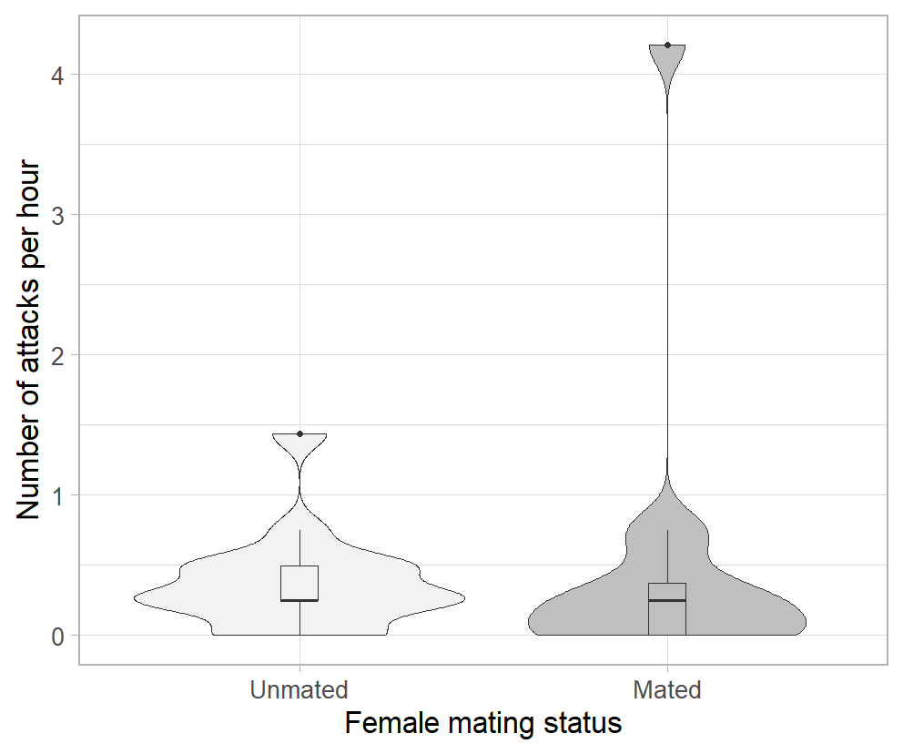

**Figure 2.** Comparison of the number of female attacks towards the male (standardised to per hour) between trials with unmated (N = 15) and already mated (same N = 15) females. Plots represent the density distribution of the number of attacks as well as the median and the interquartile and 1.5x interquartile range.

**Influence of Female Mating Status on Male Courtship Investment**

There were no significant differences in the courtship duration (V = 22, P = 0.625) and mounting duration (V = 34, P = 0.557) between groups with unmated and mated females. However, the latency to mount was significantly longer in group with mated females (unmated: mean = 4410.5 seconds, se = 561.2; mated: mean = 6687.2 seconds, se = 1150.0; V = 3, P = 0.01) (Figure 3).

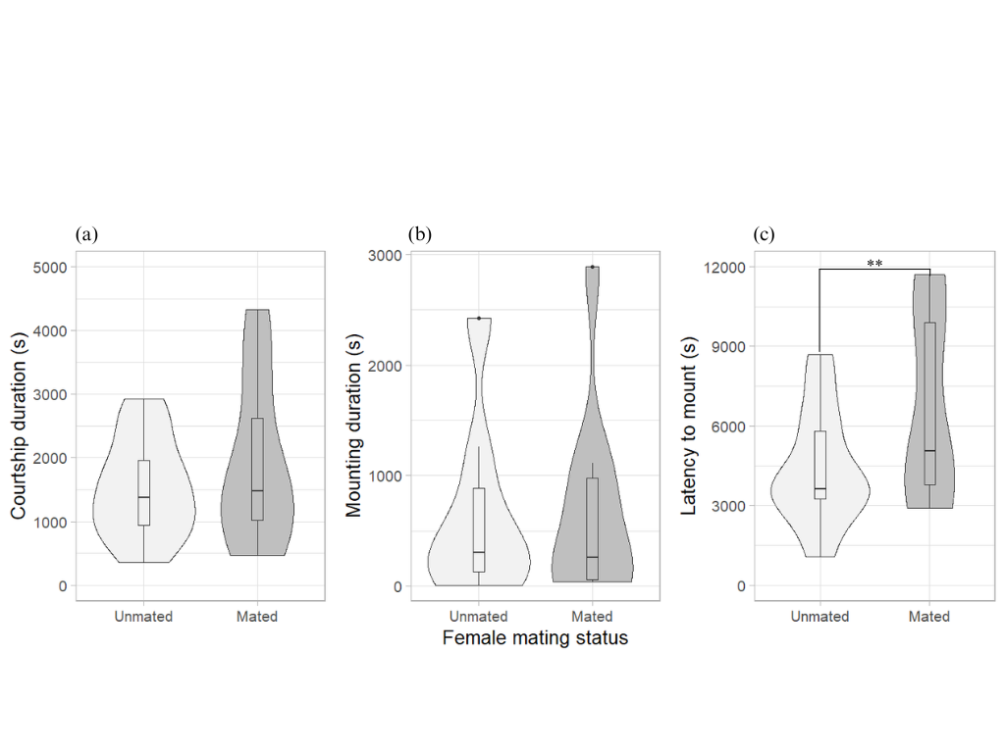

**Figure 3.** Comparison of male courtship behaviour in *Dolomedes minor* between trials with unmated and already mated females, with (a) duration of first courtship segment leading to mounting behaviour, (b) duration of first mounting behaviour and (c) latency to mount the female. Plots represent the density distribution of the variable as well as the median and the interquartile and 1.5x interquartile range. A significant difference in the latency to mount between groups is denoted by \*\* (p = 0.01).

**Influence of Female Mating Status on Male Courtship Structure**

A total of 15 mating trials with unmated females and 10 mating trials with already mated females were scored for the analysis of courtship structure. In both groups, a total of 14 behaviours and 32 significant transitions were mapped (Figure 4). For accuracy, all leg motions were grouped as ‘Leg Display’ (Table 1) and the ‘Abdominal Tremulation’ behaviour wasn’t included in the scoring, as the male was often facing the camera or being recluded in the corner of the arena, making the difference between actual tremulation and leg movement causation ambiguous. Male courtship sequences in both groups were mainly structured around two phases. During Phase One, *D. minor* males would first approach the female, while alternating between ‘Freezing’ and visual signals. In both groups, ‘Freezing’ and ‘Leg Display’ were the most frequent behaviours in this phase and there were frequent transitions between them. Grooming behaviours were sometimes performed during this phase, but not in Phase Two. Eventually, the male approach led to Phase Two, starting with a mounting attempt. During Phase Two, ‘Freezing’ and ‘Leg & Pedipalp Display’ were the most frequent behaviour in both groups and again there were frequent transitions between each behaviour. Phase two finally resulted in either successful copulation or a retreat behaviour, often in response to a female signal. In both groups, ‘Retreat’ behaviour occurred in both phases and always led to ‘Freezing’ and the start of a new Phase one approach. Finally, there were no significant differences between any of the behaviour frequencies and behavioural transition probabilities between the two female groups, except for the ‘Leg Display’ behaviour when mounted, which was more frequent in mating trials with unmated females (V = 33, P = 0.04) (Figure 4).

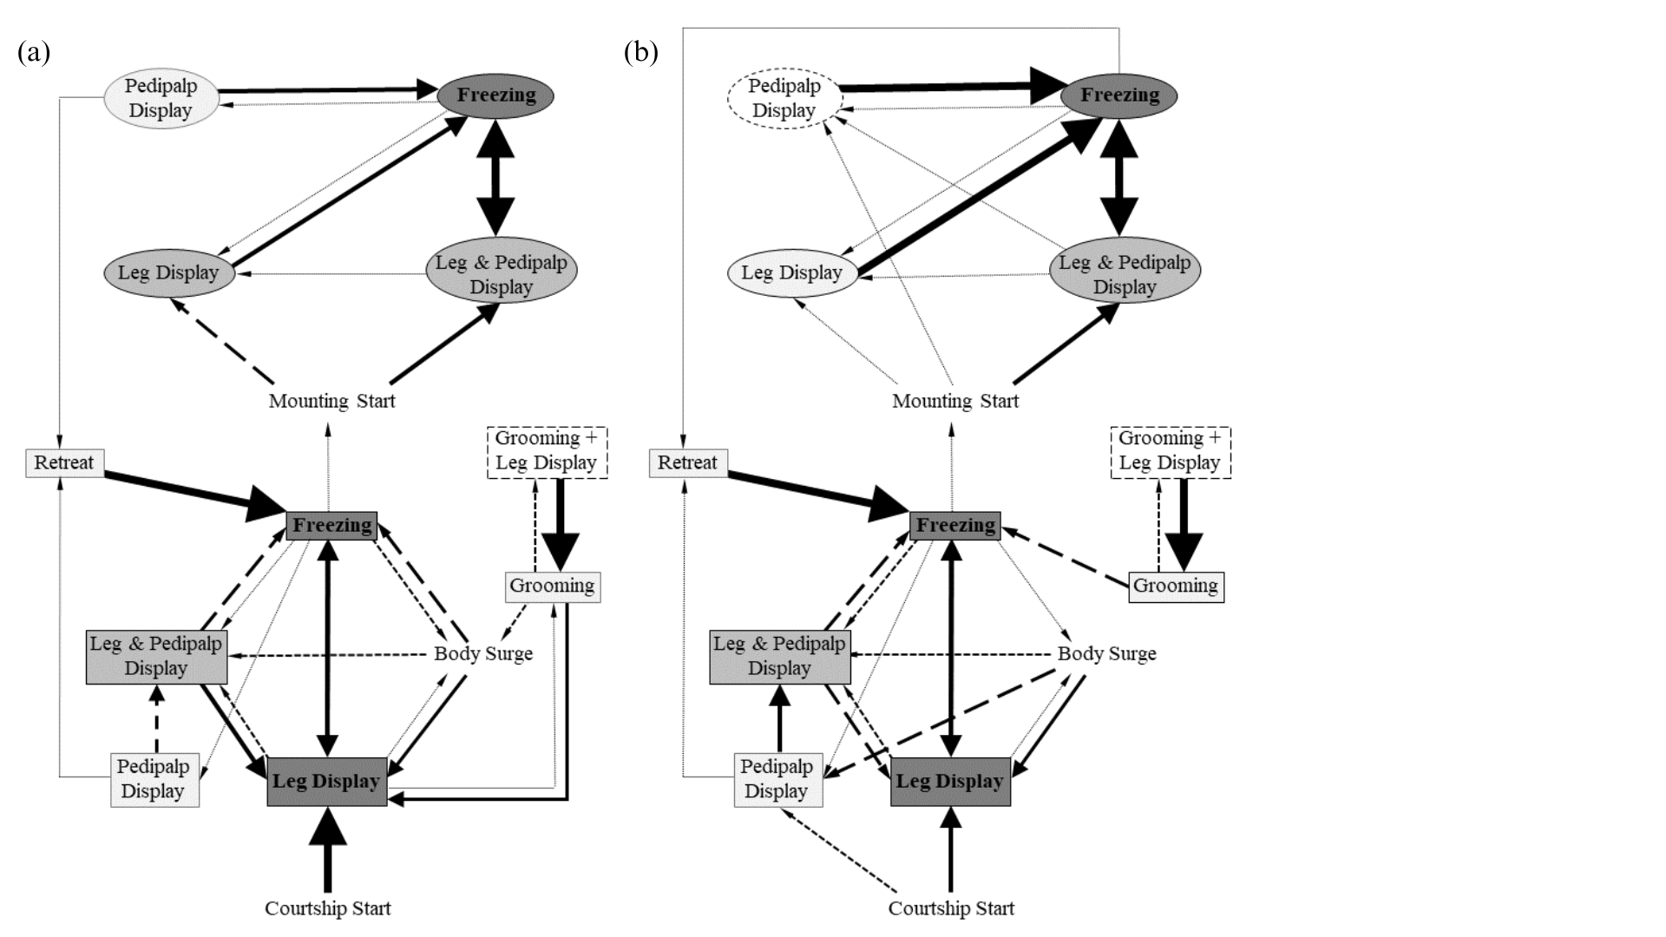

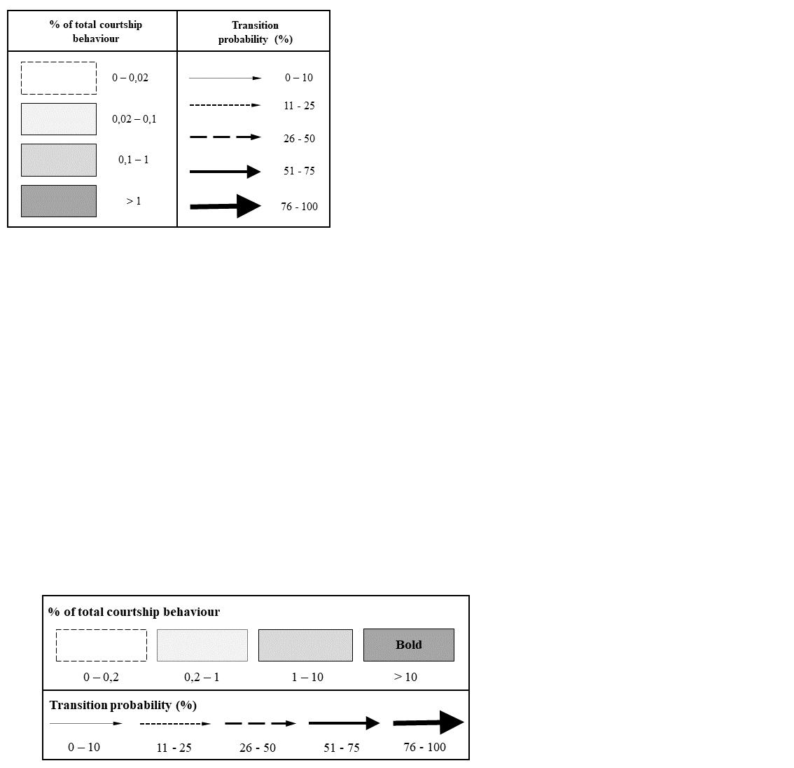

**Figure 4.** Sequential analysis of *Dolomedes minor* male courtship behaviour exhibited during mating with (a) unmated females (n = 15) and (b) already mated females (n = 10). Only behavioural transitions that were significant of the courtship structure (*i.e.* transitions that occurred significantly non randomly between behaviours) were represented. Rectangles represent behaviours exhibited by males during last approach attempt before mounting (Phase One), whereas circles represent behaviours exhibited during their first mounting on the female (Phase Two).

**DISCUSSION**

We observed that male *D. minor* displayed ritualised courtship behaviour when encountering a female, which included various visual communication signals and a diverse range of leg movements during the approach and mounting process. The aggressiveness of *D. minor* females towards males was not directly influenced by their mating status, indicating that male behaviour might not be a direct response to female attacks. We initially predicted that males might adjust their courtship behaviour when encountering already mated females for two reasons: (1) reduced female reproductive value due to sperm competition or sperm precedence patterns, and (2) increased risk of female aggressiveness, which could heighten the likelihood of death before sperm transfer. However, in contrast to our prediction, courtship and mounting durations were not found to be dependent on female mating status, however, there was a higher latency to mount in males encountering an already mated females. Overall, we therefore found little evidence that males adjust their courtship behaviour based on an assessment of female mating status prior to mating, suggesting that constraints related to sperm competition may not be the dominant factor influencing male courtship decision.

**Male Ritualised Courtship and Communication Signals**

In our observations, male *D. minor* exhibited a wide range of courtship behaviours, including various mechanical communication signals such as leg and pedipalp waving, as well as tapping on the substrate. These behaviours were consistently observed during the male’s approach and the mounting process. The presence of vibrational and visual signals in courtship behaviour is a common characteristic among spider families closely related to fishing spiders, including lycosid and pisaurids (Eberhard *et al*., 2020; Gibson & Uetz, 2008; Hebets, 2005; Hebets & Uetz, 1999; Hoefler *et al*., 2008). Previous studies on several *Dolomedes* species, such as *D. triton*, *D. fimbriatus*, and *D. scribens*, have already documented the occurrence of vibrational and visual signals during courtship, including abdominal vibration, leg movements, and following the female’s silk draglines (Arnqvist, 1992; Kaston, 1936; Roland & Rovner, 1893). These previous findings align with the courtship behaviour of *D. minor* observed in our study.

The role of vibrational communication signals emitted by male spiders during courtship has been extensively investigated, particularly in web-building spiders where vibrations are transmitted through the female’s web (Vibert *et al.*, 2016). Numerous studies have focused on describing these signals and their effects, including stimulating receptive females to mate, which may vary depending on female mating status, as well as reducing the risk of cannibalism (Maklakov *et al*., 2003; Sivalinghem & Mason, 2020; Wignall & Herberstein, 2013). Although wandering spiders do not build webs for prey capture, females produce silk draglines that have been observed to be followed by males emitting vibrational communication signals (Gibson & Uetz, 2008; Tietjen & Rovner, 1980). Similar silk-following behaviours have been described in pisaurid spiders, and the importance of vibrational sensitivity has been demonstrated in their reproductive behavior, enabling females to distinguish conspecific males from prey (Arnqvist, 1992; Barth, 1985; Bleckmann & Barth, 1984; Bleckmann & Bender, 1987). These studies support the idea that male spiders may make investment decisions in their vibrational communication behaviour to minimize their risk of cannibalism and enhance female acceptance.

Such behaviours, which heavily rely on motor performance, likely impose an energetic cost on the male throughout the entire courtship display (Clark, 2012). Courtship costs have been documented in various animal species, including spiders, and are known to depend on the male's condition and energy allocation ability (Byers et al., 2010; Hoefler et al., 2008). Additionally, females exhibited sexual cannibalism behaviour towards males. Our findings confirm that male *D. minor* spiders engage in a ritualized pre-copulatory courtship behaviour with behavioural requirements that may result in an evolutionary compromise. During their courtship, males may experience an energetic cost associated with female acceptance while simultaneously trying to evade sexual cannibalism.

**Courtship Behaviour Depending on Female Mating Status**

Female mating status has previously been shown to be important for male mate choice, including courtship behaviour, in several spider species. For instance, in funnel web spiders (Atracidae), males have been demonstrated to prefer unmated females and exhibit different courtship behaviours (Riechert & Singer, 1995). Similarly, lycosid spiders have been found to employ different mating strategies depending on the female mating status, with shorter mounting latency when the female was already mated (Bunch & Wilgers, 2011). However, contrary to our prediction, we found little evidence that *D. minor* males adjust their courtship investment in response to female mating status. Our study demonstrated that the duration of courtship and mounting in *D. minor* was not influenced by the female mating status. Furthermore, apart from a reduced frequency of leg display behaviours during mounting when the female was already mated, female mating status did not impact the overall structure of male courtship behaviour. Surprisingly, we even found evidence that contradicts the literature, with males displaying longer mounting latency when the female was already mated.

Chemical cues emitted by females likely play an important role in the way males assess the mating status of their potential partners (Thomas, 2010; Tuni & Berger-Tal, 2012). These cues may arise from the transfer of male cuticular hydrocarbons to females during copulation, serving to deter sperm competition from other males (Rypstra et al., 2003; Thomas, 2010). In *Dolomedes* spiders, Roland & Rovner (1983) investigated the production of chemical compounds by females that trigger male courtship behaviour. They found that this compound is released on the female silk dragline and the water's surface, rather than in the air. They also observed that the courtship response of *D. triton* males was stronger when the female had been in contact with water for a longer duration, which aligned with field observations of the species. In our study, we introduced females into the mating arenas for only 10 minutes before introducing the males, and the short acclimatization time may have limited the opportunity for females to release pheromones or leave chemical cues via silk draglines in the mating arena. As *D. minor* spiders do not typically associate with water in their habitat, water is unlikely to be an important substrate through which cues travel for this species. Nonetheless, this short acclimatization time might have restricted the male's ability to detect chemical indicators of female mating status. Further investigations are warranted to explore the role of chemical cues in male-female interactions in *D. minor* and how they influence courtship behaviour and mating decisions.

Our study focused solely on the courtship behavior that occurred prior to physical contact between the male and female. Therefore, it is possible that *D. minor* males receive information about female mating status through direct contact rather than relying solely on chemical cues left behind on drag lines. For example, in many spider species, males employ mating plugs to block the female's genitalia, reducing sperm competition from other males (Uhl et al., 2010). Observations of genital mutilation have also been made in the *Dolomedes* genus, particularly in *D. tenebrosus* (Schwartz et al., 2013). In such cases, copulatory plugs represent an additional disadvantage for males encountering an already mated female and are likely assessed by males upon direct contact with the female genitalia (Parker et al., 1996; Uhl et al., 2010). If *D. minor* males were capable of assessing female mating status from a distance through chemical cues, we would have expected to find evidence of adjustments in male courtship behavior. Therefore, it is plausible that the assessment of female mating status may require direct contact with the female. In such a scenario, energetic adjustment might not be primarily related to courtship behavior but rather to later parameters such as copulation probability and ejaculate quality and quantity. Further research is needed to investigate the role of direct contact and copulatory plugs in male-female interactions in *D. minor* and how they influence male mating decisions and investment strategies.

**CONCLUSION**

When encountering a female, *Dolomedes minor* males display ritualized courtship behaviours characterized by a diverse array of visual and vibrational signals. Our study provides the first comprehensive description of male courtship behaviour in this species, which aligns with the previously documented vibrational and visual signals observed in other spiders, including other *Dolomedes*. Contrary to our prediction, the mating status of the female did not have a significant impact on male investment in courtship, mating duration, or courtship structure. These findings lay the groundwork for future investigations into male courtship behaviours in *D. minor*. We propose that factors such as vibrational frequency, chemical cues, and physical contact between individuals may influence male courtship decisions and the assessment of female quality. Additionally, male evaluation of female mating status may lead to adaptations beyond courtship modifications, such as changes in copulation probability or the quality and quantity of sperm ejaculated, particularly in response to potential copulatory plugs. Furthermore, this study offers preliminary insights into the mating system and the occurrence of sexual cannibalism in *Dolomedes minor*, providing a basis for further investigations to elucidate the factors driving the adaptive strategies employed by both males and females during their reproduction. The interplay between courtship behaviours, male investment decisions, and reproductive outcomes in this species warrants further exploration and could provide valuable insights into the complex dynamics of spider mating systems.

REFERENCES

Ancillotto L., Vignoli L., Martino J., Paoletti C., Romano A., Bruni G. (2022). Sexual dichromatism and throat display in spectacled salamanders: a role in visual communication? *Journal of Zoology*, 318:75-83.

Andersson M., Iwasa Y. (1994). Sexual selection. *Trends in Ecology & Evolution*, 11(2):53-8.

Andrade, M. C. (2003). Risky mate search and male self-sacrifice in redback spiders. *Behavioral Ecology*, 14(4), 531-538.

Arnqvist G. (1992). Courtship behavior and sexual cannibalism in the semi-aquatic fishing spider, *Dolomedes fimbriatus* (Clerck) (Araneae: Pisauridae). *The Journal of Arachnology*, 20:222-226.

Arnqvist, G. & Henriksson, S. (1997). Sexual cannibalism in the fishing spider and a model for the evolution of sexual cannibalism based on genetic constraints. *Evolutionary Ecology*, 11, 255-273.

Ayasse M., Engels W., Lübke G., Taghizadeh T., Francke W. (1999). Mating expenditures reduced via female sex pheromone modulation in the primitively eusocial halictine bee, *Lasioglossum* (*Evylaeus*) *malachurum* (Hymenoptera: Halictidae). *Behavioral Ecology and Sociobiology*, 45:95-106.

Bakeman R., Robinson B. F., Quera V. (1996). Testing sequential association: Estimating exact p values using sampled permutations. *Psychological Methods*, 1:4-15.

Barske, J., Fusani, L., Wikelski, M., Feng, N. Y., Santos, M., & Schlinger, B. A. (2014). Energetics of the acrobatic courtship in male golden-collared manakins (*Manacus vitellinus*). *Proceedings of the Royal Society B: Biological Sciences*, 281(1776), 20132482.

Bastock M. (1967). Courtship: a zoological study. Vol. 4. *Transaction Publishers*.

Bleckmann H., Lotz T. (1987). The vertebrate-catching behaviour of the fishing spider *Dolomedes triton* (Araneae, Pisauridae). *Animal Behaviour*, 35:641-651.

Cargnelutti F., Calbacho-Rosa L., Cordoba-Aguilar A., Peretti A. V. (2022). Successive matings affect copulatory courtship but not sperm transfer in a spider model. *Biological Journal of the Linnean Society*, 135:299-309.

Chiarle A., Kronestedt T., Isaia M. (2013). Courtship behavior in European species of the genus *Pardosa* (Araneae, Lycosidae). *The Journal of Arachnology*, 41:108-125.

Copperi M. S., Ferretti N., Peretti A. V. (2019). The role of silk in courtship and communication in mygalomorph spiders: Do males regulate their courtship in response to female mating status? *Behavioural Processes*, 167.

Cory A., Schneider J. (2020). Males of sexually cannibalistic spider chemically assess relative female quality. *BMC Evolutionary Biology*, 20:90.

Csardi G., Nepusz T. (2006). The igraph software package for complex network research. *InterHournal, Complex Systems*. URL: [https://igraph.org](https://igraph.org" \t "_new).

Eberhard M. J. B., Machnis A., Uhl G. (2020). Condition-dependent differences in male vibratory pre-copulatory and copulatory courtship in a nuptial gift-giving spider. *Behavioral Ecology and Sociobiology*, 74:138.

Elgar M. A. (1992). Sexual cannibalism in spiders and other invertebrates. In Elgar M. A., Crespi B. J. (1992) *Cannibalism: Ecology and evolution among diverse taxa*. Oxford University Press, pp128-155.

Fisher A. M., Price T. A. R. (2019). Density-dependent aggression, courtship, and sex ratio in a fishing spider. *Arachnology*, 18:295-300.

Friard O., Gamba M. (2016). BORIS: a free, versatile open-source event-logging software for video/audio coding and live observations. *Methods in Ecology and Evolution*, 7:1325–1330.

Gaskett A. C., Herberstein M. E., Downes B. J., Elgar M. A. (2004). Changes in male mate choice in a sexually cannibalistic orb-web spider (Araneae: Araneidae). *Behaviour*, 141:1197-1210.

Girard M. B., Elias D. O., Kasumovic M. M. (2015). Female preference for multi-modal courtship: multiple signals are important for male mating success in peacock spiders. *Proceedings Royal Society B*, 282:20152222.

Green P. A., Patek S. N. (2018). Mutual assessment during ritualized fighting in mantis shrimp (*Stomatopoda*). *Proceeding Royal Society B*, 285:20172542.

Henschel J. R. (1994). Predation on social and solitary individuals of the spider *Stegodyphus dumicola* (Eresidae). *Journal of Arachnology*, 22:348-351.

Henschel J. R., Lubin Y. (1997). A test of habitat selection at two spatial scales in a sit-and-wait predator: a web-building spider. *Animal Behaviour*, 54:1021-1033.

Kasumovic M. M., Elias D. O., Sivalinghem S., Mason A. C., Andrade M. C. B. (2010). Examination of condition dependence and genotype-by-environment interactions in the maintenance of a sexually selected trait. *Proceedings of the Royal Society B: Biological Sciences*, 277(1687), 2843-2850.

LeGrice, R. J., Holwell, G. I., & Painting, C. J. (2024). Sequential analysis reveals use of mutual assessment in contests between wild New Zealand giraffe weevils. *New Zealand Journal of Zoology*, *51*(2), 240-257.

Lotz T. N. (2018). Male investment during courtship and copulation: Assessing the cost of mating strategies in sexually cannibalistic spiders. *Behavioral Ecology and Sociobiology*, 72:36.

Maklakov A. A., Bilde T., Lubin Y. (2003). Effects of social environment on sexual competition in a spider with last-male sperm precedence. *Proceedings of the Royal Society B: Biological Sciences*, 270(1525), 159-162.

Peretti A. V., Carrera P. C., Pascual N. A. (2006). Functional morphology and sexual selection in male genitalia of the spider *Scytodes globula* (Scytodidae). *Journal of Morphology*, 267(5):560-572.

Schneider J. M., Fromhage L., Uhl G. (2005). Copulation patterns in the spider *Argiope bruennichi* (Araneae: Araneidae): female control and male compromise. *Behavioral Ecology and Sociobiology*, 58:390-396.

Stoltz J. A., Elias D. O., Andrade M. C. B. (2009). Female preference for male courtship effort in the redback spider (*Latrodectus hasselti*). *Behavioral Ecology*, 20(3), 745-752.

Uhl G., Nessler S. H., Schneider J. M. (2007). Copulatory mechanism in a sexually cannibalistic spider with genital damage. *Frontiers in Zoology*, 4:22.

Watson P. J., Lighton J. R. B., Miller G. L. (1993). Sexual selection: Mechanical constraints in the evolution of sexually dimorphic spider genitalia. *Functional Ecology*, 7:119-125.